Experiment 17:
Aim:
17.Write a Pandas program to split the following dataframe by school code and get mean, min, and max value of age for each school.
Python code:
import pandas as pd

# Create DataFrame
data = {
"school_code": ["s001", "s002", "s003", "s001", "s002", "s004"],
"class": ["V", "V", "VI", "VI", "V", "VI"],
"name": ["Alberto Franco", "Gino Mcneill", "Ryan Parkes", "Eesha Hinton", "Gino Mcneill", "David Parkes"],
"date_Of_Birth": ["15/05/2002", "17/05/2002", "16/02/1999", "25/09/1998", "11/05/2002", "15/09/1997"],
"age": [12, 12, 13, 13, 14, 12]
}
df = pd.DataFrame(data)
print("Original DataFrame:")
print(df)

# Split by school code and get mean, min, max of age
grouped = df.groupby("school_code")["age"].agg(["mean", "min", "max"])
print("\nMean, min, and max age for each school:")
print(grouped)
Output:
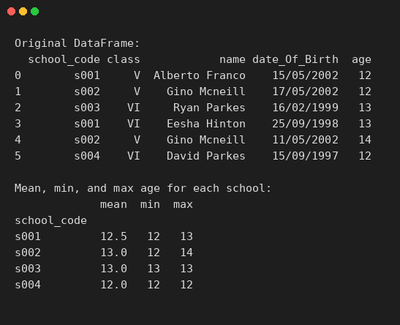
Experiment 18:
Aim:
18.Write a Pandas program to split the following given dataframe into groups based on school code and class.
Python code:
import pandas as pd

# Create DataFrame
data = {
"school_code": ["s001", "s002", "s003", "s001", "s002", "s004"],
"class": ["V", "V", "VI", "VI", "V", "VI"],
"name": ["Alberto Franco", "Gino Mcneill", "Ryan Parkes", "Eesha Hinton", "Gino Mcneill", "David Parkes"],
"date_Of_Birth": ["15/05/2002", "17/05/2002", "16/02/1999", "25/09/1998", "11/05/2002", "15/09/1997"],
"age": [12, 12, 13, 13, 14, 12]
}
df = pd.DataFrame(data)
print("Original DataFrame:")
print(df)

# Split the DataFrame into groups based on school code and class
grouped = df.groupby(["school_code", "class"])
print("\nSplit into groups based on school code and class:")
for name, group in grouped:
print("\nGroup:", name)
print(group)
Output:
